2018 – 2019

Research rapport – labo4

Controlling diddyborg v2 with a wiimote

jeroen vervaeck – Yoram PlatTEEUW

Table of content

1. Intro 2

2. Diddyborg inisalising 2

3. Installing the ThunderBorg: 3

4. Connecting Wii controller with Raspberry Pi 4

5. Mapping Wiimote input with python 8

6. Adressing Thunderborg 11

7. Starting program on boot 13

Run program on boot 13

connect bluethoot on boot 13

8. Extra’s 14

9. Sources 15

## 1. Intro

The **Diddyborg v2** is a robot kit from PiBorg. It’s a mount which is controlled by six motors. De power comes from AA batteries. It’s possible to attach extra tools to the robot to make it more functional.

## 2. Diddyborg inisalising

**step 1**

Connect the Raspberry Pi from the Diddyborg to a screen (Or via SSH). Make sure the SD cart contains the newest version of Raspbian.

**Step 2**

Connect the batterie pack to the Thunderborg.

**Step 3**

Hdmi kabel aansluiten op een scherm

Connect the HDMI cable to a screen.

A Keyboard and mouse to control the RaspberryPi is also recommended.

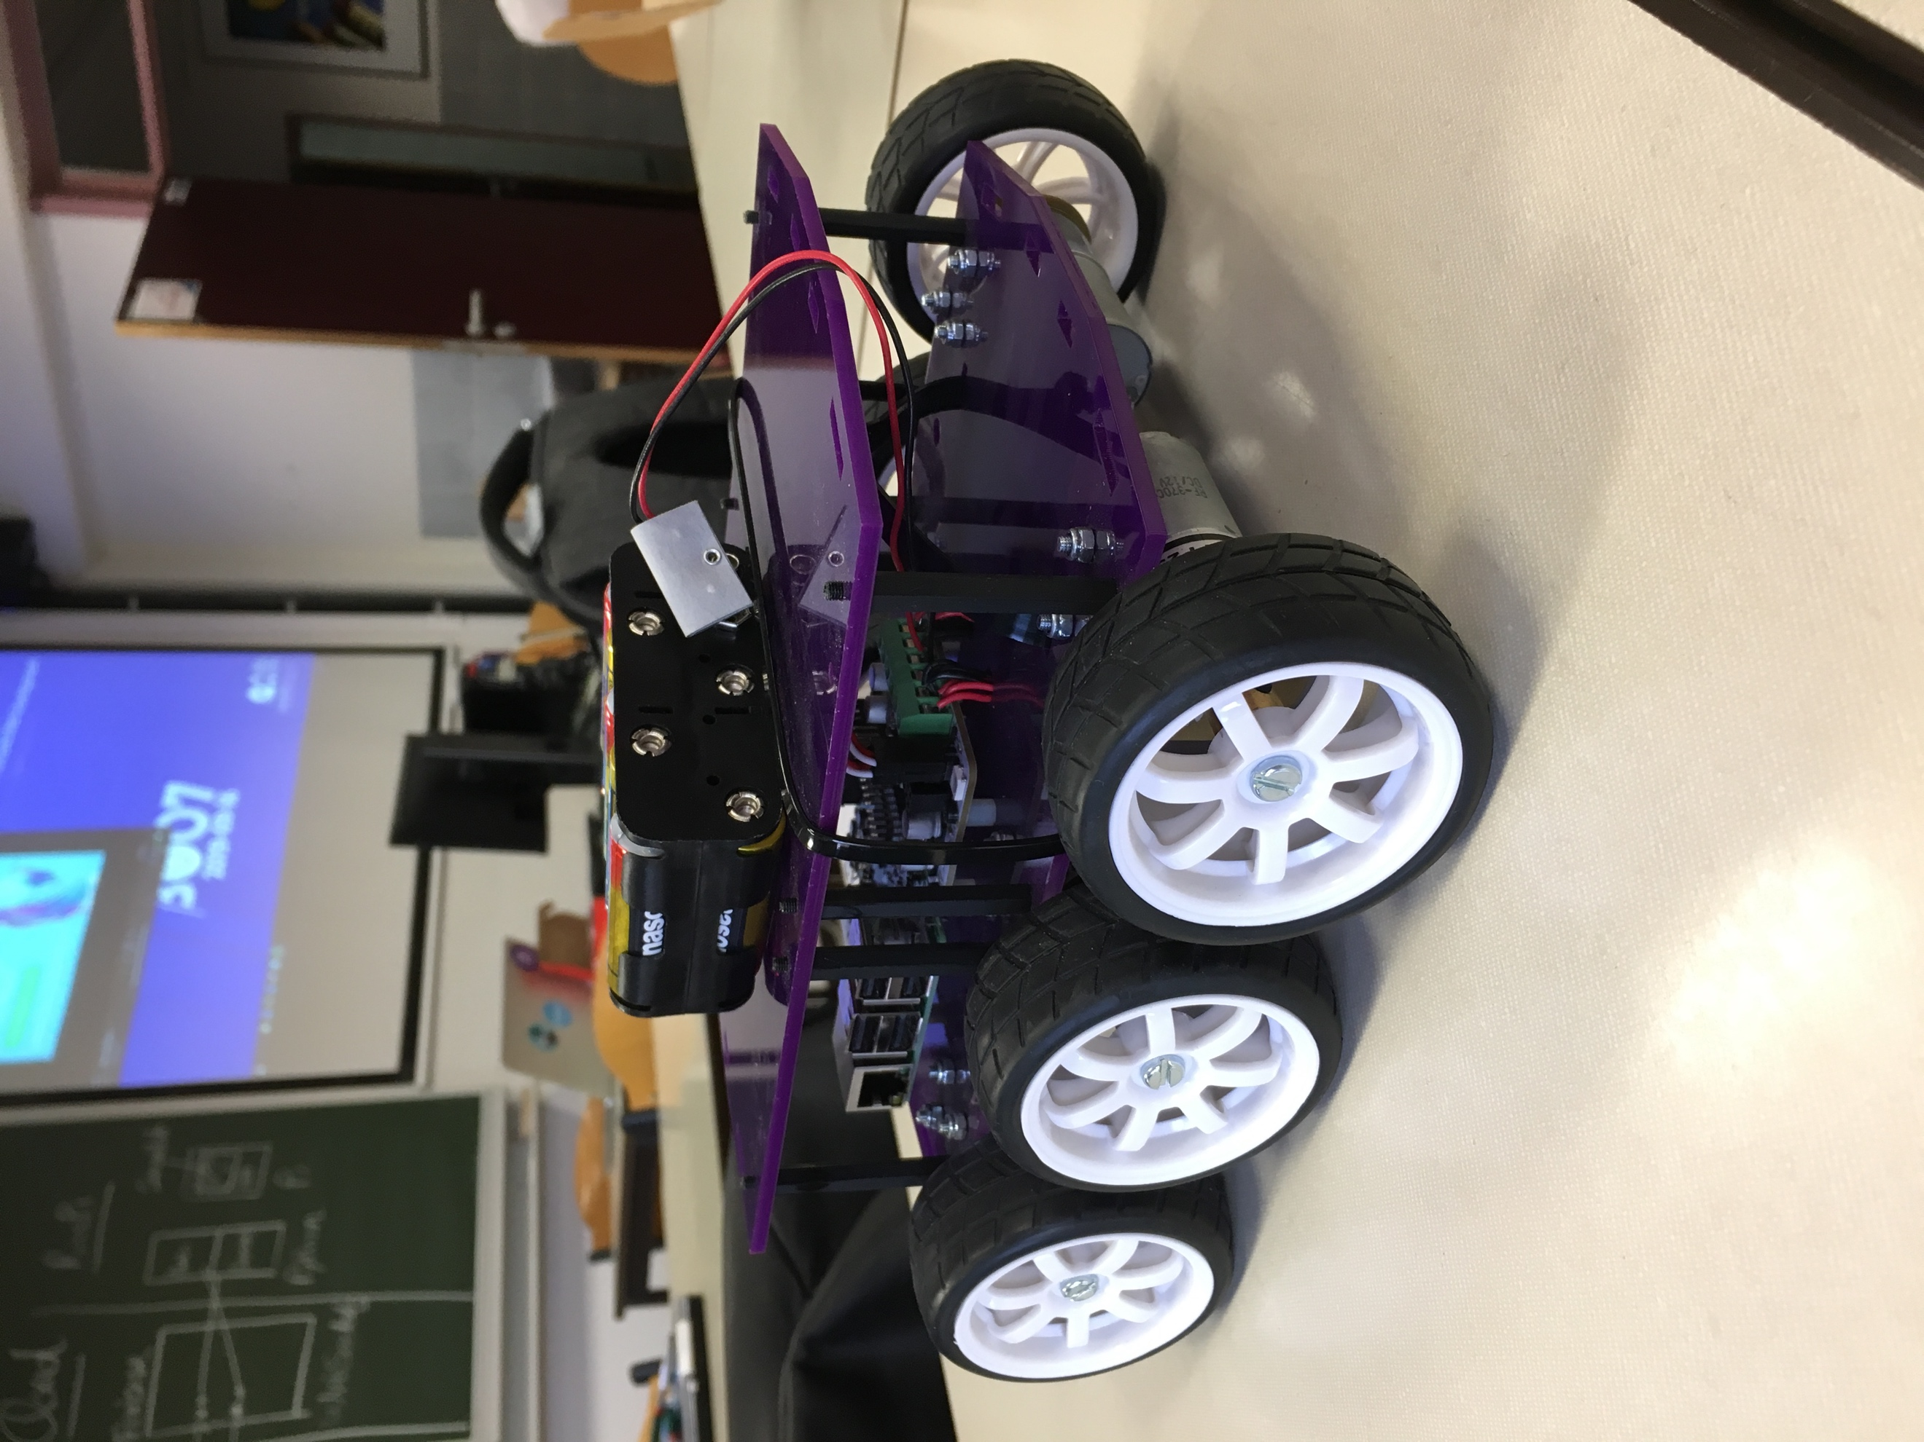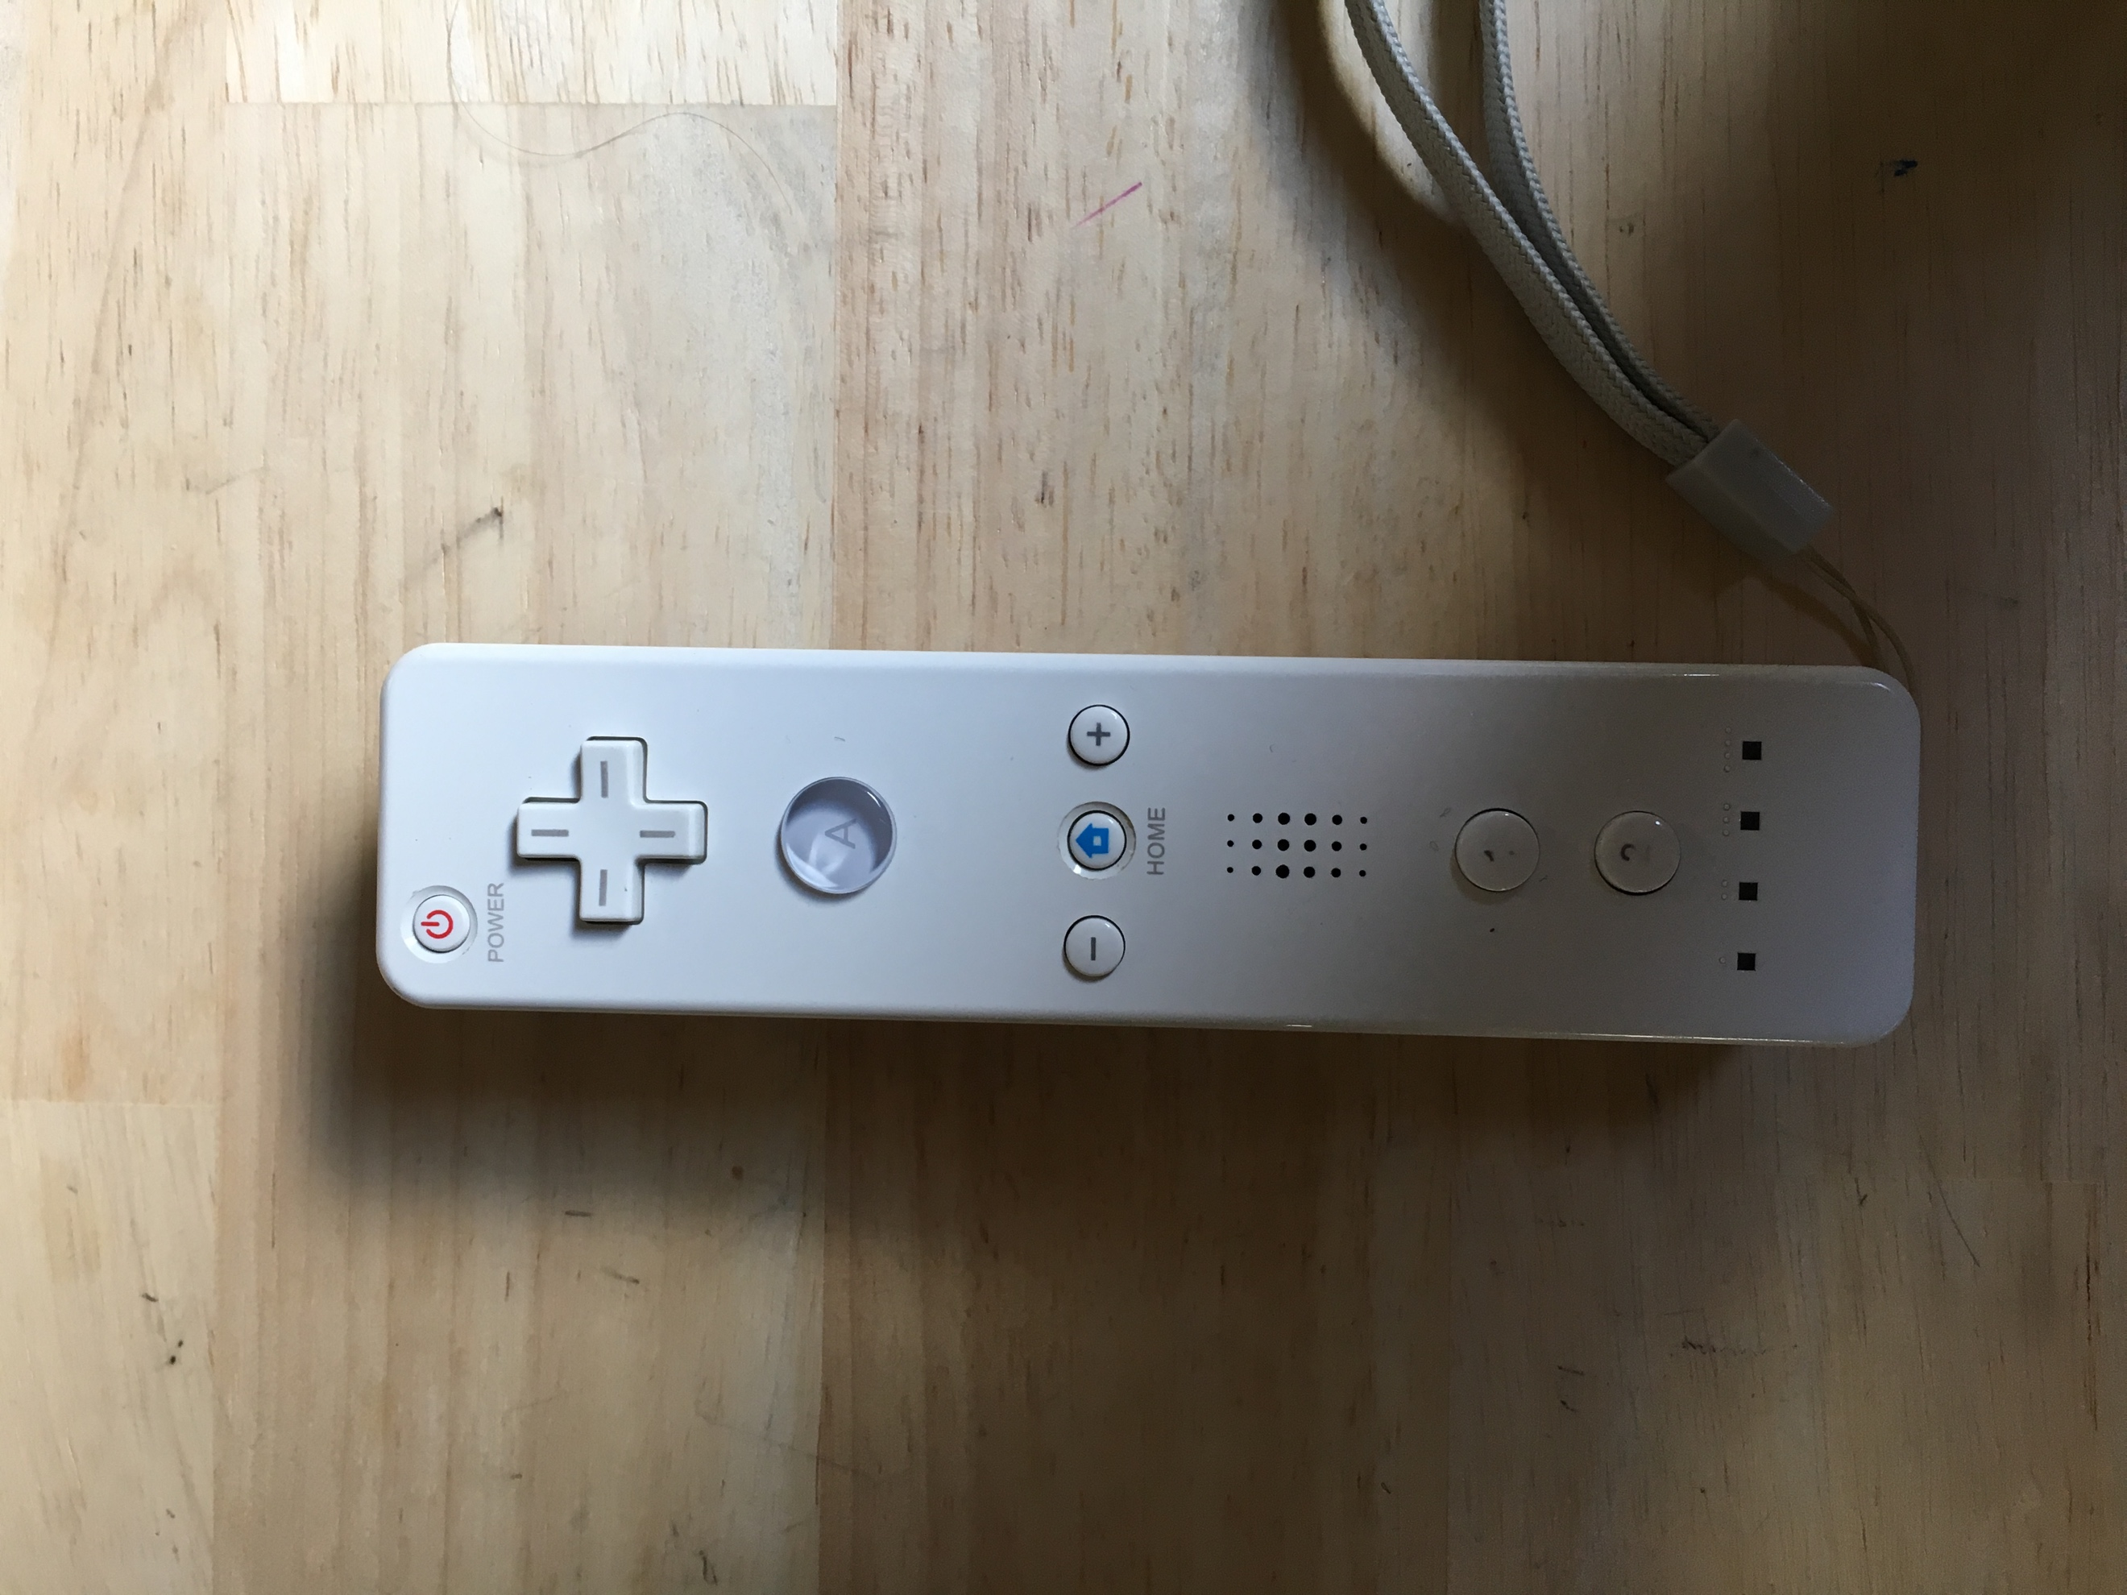

Source1: Diddyborg v2 Source2: Wiimote

## 3. Installing the ThunderBorg:

**DiddyBorg v2** uses a **[ThunderBorg](https://www.piborg.org/thunderborg)** to drive the motors. We will connect the board later, for now we simply need to install the software to control it. **DiddyBorg** requires **I2C** to be enabled. If you have not done this before you can do this by:

Enter the following command in a terminal: sudo raspi-config

Move down to **option 5** Interfacing Options and press ENTER

Move down to **option P5 I2C**and press ENTER

Make sure **Yes** is highlighted and press ENTER

When the dialog says **I2C is enabled** press ENTER

Move right until **Finish** is highlighted, then press ENTER

---

To run through the automatic installer just use this one line in a terminal:

bash <(curl <https://www.piborg.org/installer/install-diddyborg-v2.txt>)

---

If you would prefer to manually run through the steps use the commands below:

mkdir ~/thunderborg

cd ~/thunderborg

wget http://www.piborg.org/downloads/thunderborg/examples.zip

unzip examples.zip

chmod +x install.sh

./install.sh

mkdir ~/diddyborgv2

cd ~/diddyborgv2

wget http://www.piborg.org/downloads/diddyborgv2/examples.zip

unzip examples.zip

chmod +x install.sh

./install.sh

Once you have done this you will have two sets of examples:

ThunderBorg examples in ~/thunderborg The basic motor output and LED control examples will have links on the desktop

DiddyBorg v2 examples in ~/diddyborgv2 This includes some standard examples such as remote control using a gamepad or joystick

This step will download some filles to the RaspberryPi. They will be used later on.

## 4. Connecting Wii controller with Raspberry Pi

<https://www.instructables.com/id/Wiimote-Controller-Configuration-for-Raspberry-Pi-/>

Update the existing software on your Raspberry Pi. We will be using the Linux Command line to perform all of the commands.

sudo apt-get update

sudo apt-get upgrade

---

The packages "cwiid" and "wminput" were created to interface the Wiimote and Raspberry Pi via bluetooth. The "cwiid" package is the Linux to Nintendo Wiimote interface. The "wminput" is a Linux event, mouse, and joystick driver for the wiimote using the uinput system.

sudo apt-get install python-cwiid

sudo apt-get install wminput

---

We need to change the udev rules so the uinput device will work with non-root users. We will do this by adding wiimote.rules to /etc/udev/rules.d.

sudo nano /etc/udev/rules.d/wiimote.rules

Copy and paste the following into the file. Then save this file.

KERNEL=="uinput", MODE="0666"

---

In order to implement the changes that you made to the rules file, you must either reboot the Raspberry Pi or restart the udev service.

sudo shutdown -r now

---

We will be using the bluetooth to connect to the Wiimotes. Check the status by typing the following:

/etc/init.d/bluetooth status

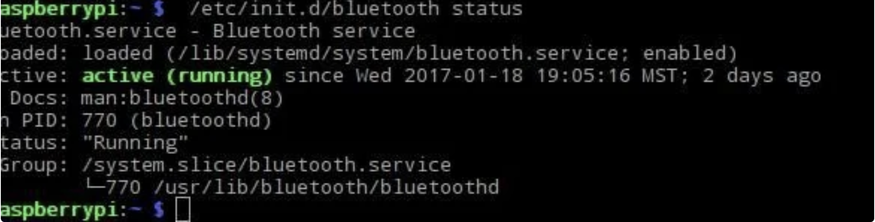

---

**Configuring Wiimote Buttons in Wminput.**

Each Wiimote will need its own controller mapping. My configuration file will have controller mappings for the Wiimote and Nunchuk Buttons.

Create the file with the following command:

sudo nano /home/pi/mywinput

Next, Copy and paste this into the file:

#WiiMote

Wiimote.A = BTN_A

Wiimote.B = BTN_B

Wiimote.Dpad.X = ABS_Y

Wiimote.Dpad.Y = -ABS_X

Wiimote.Minus = BTN_SELECT

Wiimote.Plus = BTN_START

Wiimote.Home = BTN_MODE

Wiimote.1 = BTN_X

Wiimote.2 = BTN_Y

# Nunchuk

Nunchuk.C = BTN_C

Nunchuk.Z = BTN_Z

**---**

**Activate the LED's on the Wiimote**

The Wiimote will work without this step, but if you would like to see that your Wiimote is connected or which controller mapping is currently mapped to that Wiimote, follow this step.

Add the following to the bottom of the file you just created:

sudo nano /home/pi/myinput

Plugin.led.Led1 = 1

#Plugin.led.Led2 = 1

#Plugin.led.Led3 = 1

#Plugin.led.Led4 = 1

Remove the "# "on the line for the LED's you want to light up. You can go from no LED's lit to all LED's lit to everything in between.

**---**

**Get Wiimote Addresses**

**Scan for Wiimotes by typing:**

hcitool scan

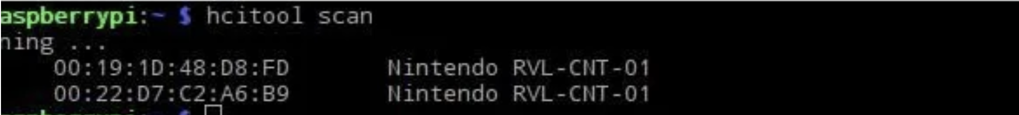

**Keep the address for later.**

**---**

**Create a Shell Script to Connect the Wiimotes**

Now we need to create a script that will connect the Wiimotes when we run it.

Create a directory and file for the script.

Make a directory by typing:

mkdir /home/pi/bin

Create the file by typing:

sudo nano /home/pi/bin/connectwii.sh

Copy and paste this into the file:

#!/bin/bash

sleep 1 # Wait until Bluetooth services are fully initialized

hcitool dev | grep hci >/dev/null

if test $? -eq 0 ; then

wminput -d -c /home/pi/mywminput 00:19:1D:48:D8:FD &

wminput -d -c /home/pi/mywminput 00:22:D7:C2:A6:B9 &

else

echo "Blue-tooth adapter not present!"

exit 1

fi

Note: you need a wminput line for each wiimote you are using.

Replace the addresses above with the addresses of your wiimotes.

If you have different controller mappings for different Wiimotes, replace “mywminput” with your controller mapping.

**Make the script just created executable by typing:**

sudo chmod 775 /home/pi/connectwii.sh

---

**Reboot your Raspberry Pi and test your script**

sudo shutdown –r now

sudo modprobe uinput

/home/pi/connectwii.sh

**Reconnect Wiimode to Bluethoot on RaspberryPi**

**---**

**Test the Wiimote**

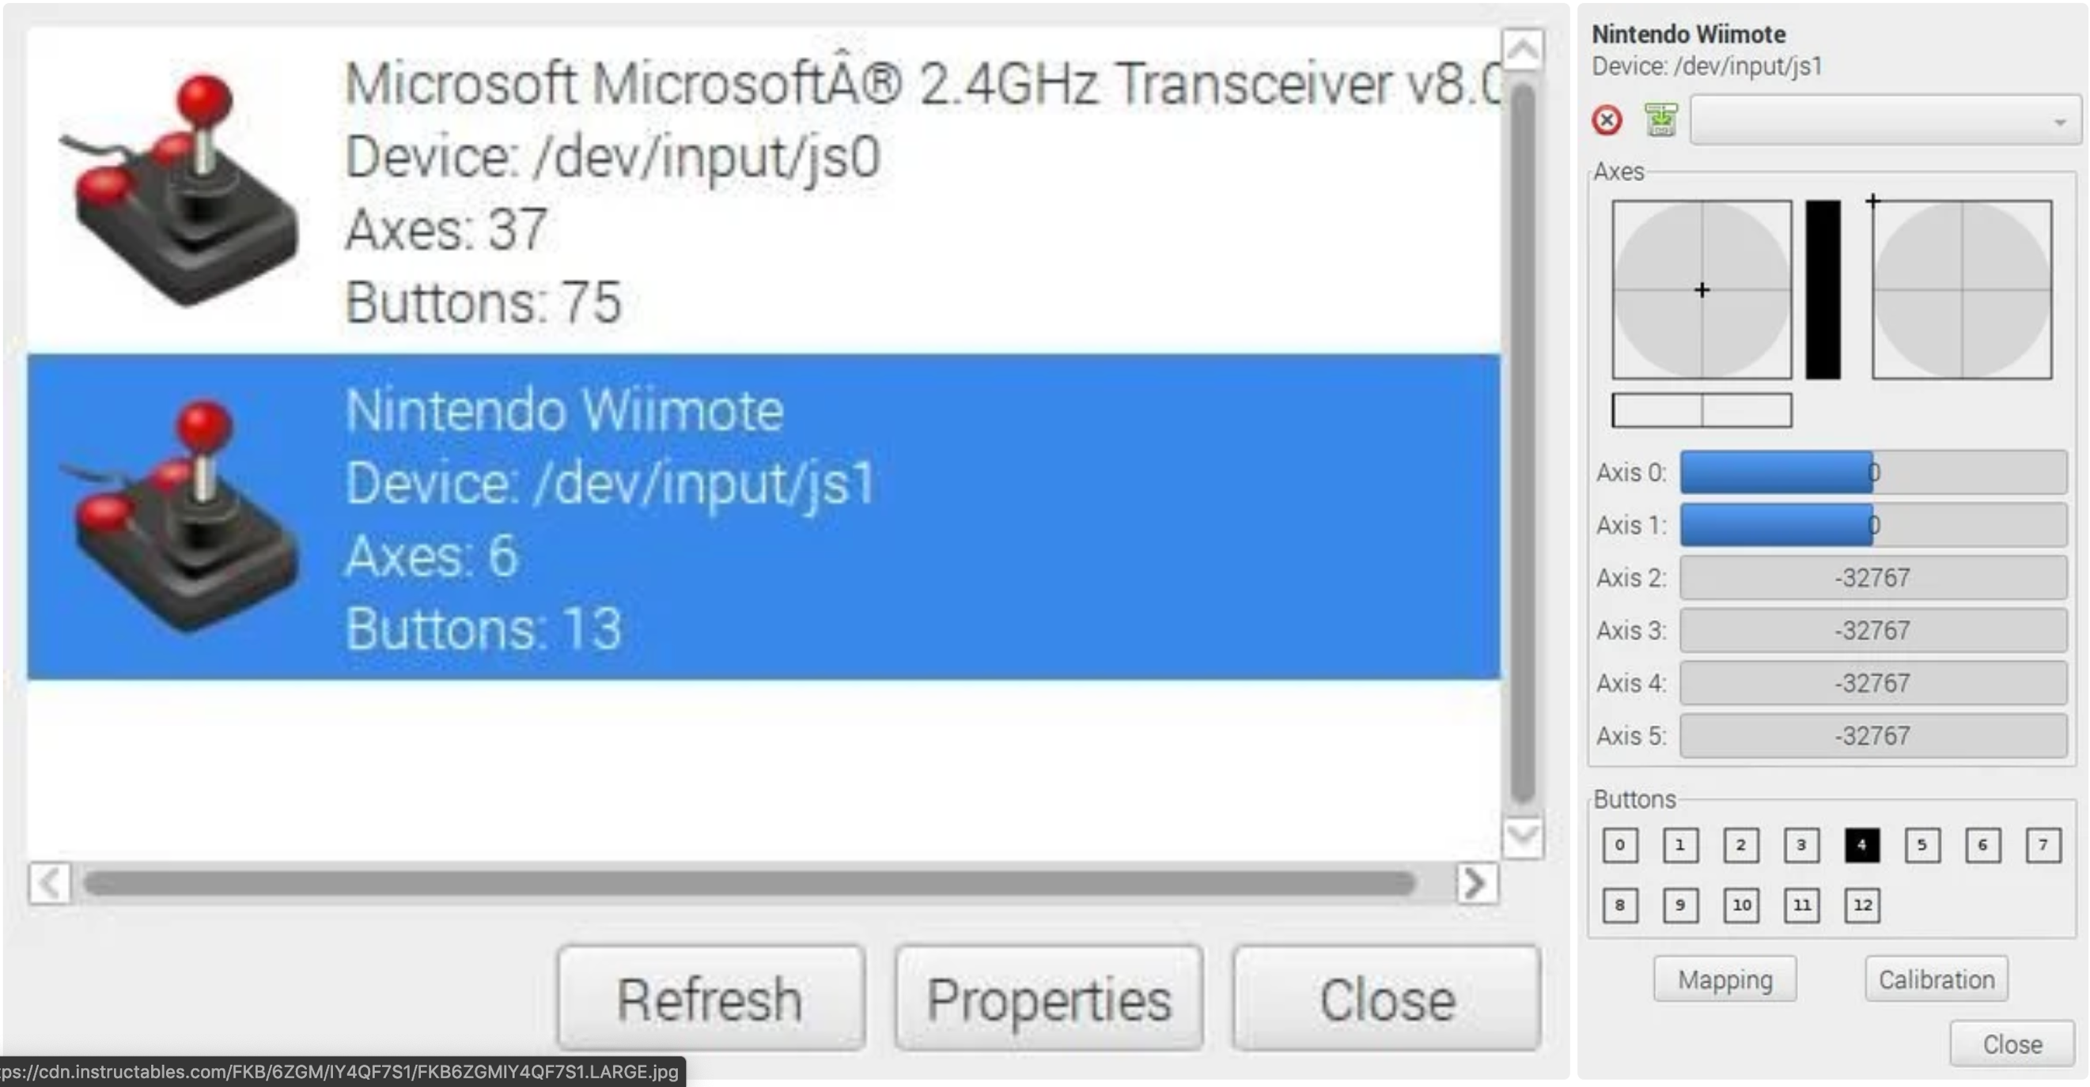

Install jstest-gtk to test your Wiimote as a controller.

sudo apt-get install jstest-gtk

jstest-gtk

You should see a gui that shows all valid inputs to test.

Select the Wiimote.

Press the buttons to see the Button Presses Register. In the picture, I am pressing the A button. You can see it register because the "Buttons 4" box transitions from white to black.

The Wiimote is configured!

## 5. Mapping Wiimote input with python

<https://core-electronics.com.au/tutorials/using-usb-and-bluetooth-controllers-with-python.html>

Every controller has different codes for their buttons.

First, we will need to write a code to see the bulk information about a buttonpress.

This first script will print all of the data to the shell, so be sure to make a note of the event codes and types for each button

We use a try except in a while loop to wait for the Wiimote to connect.

#import evdev  
from evdev import InputDevice, categorize, ecodes

#creates object 'gamepad' to store the data  
#you can call it whatever you like  
wait = True

while wait:  
gamepad = InputDevice('/dev/input/event#')

wait = False

except:

print(“waiting for wii remote to connect…”)

time.sleep(5)  
#prints out device info at start  
print(gamepad)

#evdev takes care of polling the controller in a loop  
for event in gamepad.read_loop():  
 print(categorize(event))

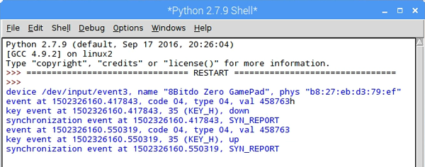

In the line “event at ##########.#####, code ##, type ##, val #####”.

The part you will need is the code. Every button has a different code. So, by pressing every button on your Wiimote, the corresponding code will appear. Take notes of the pressed button and their code. In the next step you will need them.

---

When you reconnect the Wiimote on a different moment, you need to check the path for the InputDevice(‘/dev/input.event#’). By entering the line of code in the Terminal:

<https://raspberrypi.stackexchange.com/questions/71040/how-to-know-which-file-in-dev-input-event-represent-for-touch-input-device>

Sudo apt install input-utils

lsinput

---

This code will print the pressed button to the shell. You will need to fill in your code number with the corresponding button:

#import evdev  
from evdev import InputDevice, categorize, ecodes  
  
#creates object 'gamepad' to store the data  
#you can call it whatever you like

wait = True

while wait:  
gamepad = InputDevice('/dev/input/event#')

wait = False

except:

print(“waiting for wii remote to connect…”)

time.sleep(5)  
  
#button code variables (change to suit your device)  
aBtn = ##  
  
up = ##  
down = ##  
left = ##  
right = ##  
  
#prints out device info at start  
print(gamepad)  
  
#loop and filter by event code and print the mapped label  
for event in gamepad.read_loop():  
 if event.type == ecodes.EV_KEY:  
 if event.value == 1:  
 if event.code == aBtn:  
 print("A")  
  
 elif event.code == up:  
 print("up")  
 elif event.code == down:  
 print("down")  
 elif event.code == left:  
 print("left")  
 elif event.code == right:  
 print("right")

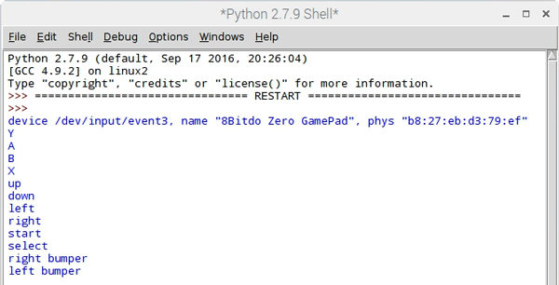

Now the buttons are mapped, and you are ready to script your Diddyborg.

## 6. Adressing Thunderborg

<https://www.piborg.org/blog/thunderborg-getting-started>

The library from Thunderborg must be installed.

**install Library**

mkdir ~/thunderborg

cd ~/thunderborg

wget http://www.piborg.org/downloads/thunderborg/examples.zip

unzip examples.zip

chmod +x install.sh

./install.sh

In the snippet of code, we download the folder **examples.zip.** This foldercontains the file **Thunderborg.py.** This file needs to **be replaced to the root folder** of your project.

**Python Library**

# Setup the library ready for use

import ThunderBorg # Load the library

TB = ThunderBorg.ThunderBorg() # Create a board object

TB.Init() # Setup the board

# Setting motor speeds

TB.SetMotor1(power) # Set motor 1 speed – waarde tussen 0 en 1

TB.SetMotor2(power) # Set motor 2 speed – waarde tussen 0 en 1

TB.SetMotors(power) # Set speed of both motors

TB.MotorsOff() # Stop both motors

# Reading motor speeds

TB.GetMotor1() # Read motor 1 speed

TB.GetMotor2() # Read motor 2 speed

# Controlling the LED

TB.SetLed1(r, g, b) # Set the colour of the ThunderBorg LED (values from 0.0 to 1.0)

TB.GetLed1() # Read the colour of the ThunderBorg LED (values from 0.0 to 1.0)

TB.SetLed2(r, g, b) # Set the colour of the ThunderBorg Lid LED (values from 0.0 to 1.0)

TB.GetLed2() # Read the colour of the ThunderBorg Lid LED (values from 0.0 to 1.0)

TB.SetLeds(r, g, b) # Set the colour of both LEDs (values from 0.0 to 1.0)

# Battery monitoring

TB.SetLedShowBattery(enabled) # Set if the LEDs reflect the current battery reading

TB.GetLedShowBattery() # Read if the LEDs reflect the current battery reading

TB.GetBatteryReading() # Read the current voltage level from the battery

TB.SetBatteryMonitoringLimits(min, max) # Set the limits for the LED based battery monitoring

TB.GetBatteryMonitoringLimits() # Read the limits for the LED based battery monitoring

# Controlling the failsafe

TB.SetCommsFailsafe(enabled) # Set if the communications failsafe is active

TB.GetCommsFailsafe() # Read if the communications failsafe is active

# Testing for faults

TB.GetDriveFault1() # See if there is a fault reported for M1

TB.GetDriveFault2() # See if there is a fault reported for M2

# RasPiO InsPiRing control

TB.SetExternalLedColours([[r,g,b], [r,g,b], [r,g,b], ..., [r,g,b]])

# Set the colour of each LED on the InsPiRing (values from 0.0 to 1.0)

# Setting parameters (before Init)

TB.i2cAddress = address # Set the address of the board to use

TB.printFunction = function # Re-route / disable diagnostic messages

# Reading parameters (after Init)

print TB.busNumber # Shows which I²C bus the board is connected on

print TB.foundChip # See if the board is found / not found

# Other functions

ThunderBorg.ScanForThunderBorg() # Sweep the I²C bus for available boards

ThunderBorg.SetNewAddress(address) # Configure the attached board with a new address

TB.Help() # Get help on the available functions

## 7. Starting program on boot

### Run program on boot

<https://www.dexterindustries.com/howto/run-a-program-on-your-raspberry-pi-at-startup/>

All lines in rs.local get executed on boot:

sudo nano /etc/rc.local

To start diddy.py on boot add the line:

sudo python PATH TO YOUR FILE &

was added to /etc/rc.local

Now the program will execute without entering a screen first.

### connect bluethoot on boot

<https://www.instructables.com/id/Auto-Connection-of-the-Bluetooth-and-Auto-Running-/>

<https://pimylifeup.com/raspberry-pi-wiimote-controllers/>

## 8. Extra’s

When you need to reconnect the Wiimote to the RaspberryPi, you need to use the sync button on the back of the Wiimote. (see source3 - 4)

Make sure the check the path on the tutorials. They could be different. When we were installing the files, we had to change some paths.

You have to wait 20 seconds before pressing a button on the Wiimote, because the rasspberrypi needs to boot

When the Wiimote has a pin request, you need to try again. This will fix the problem.

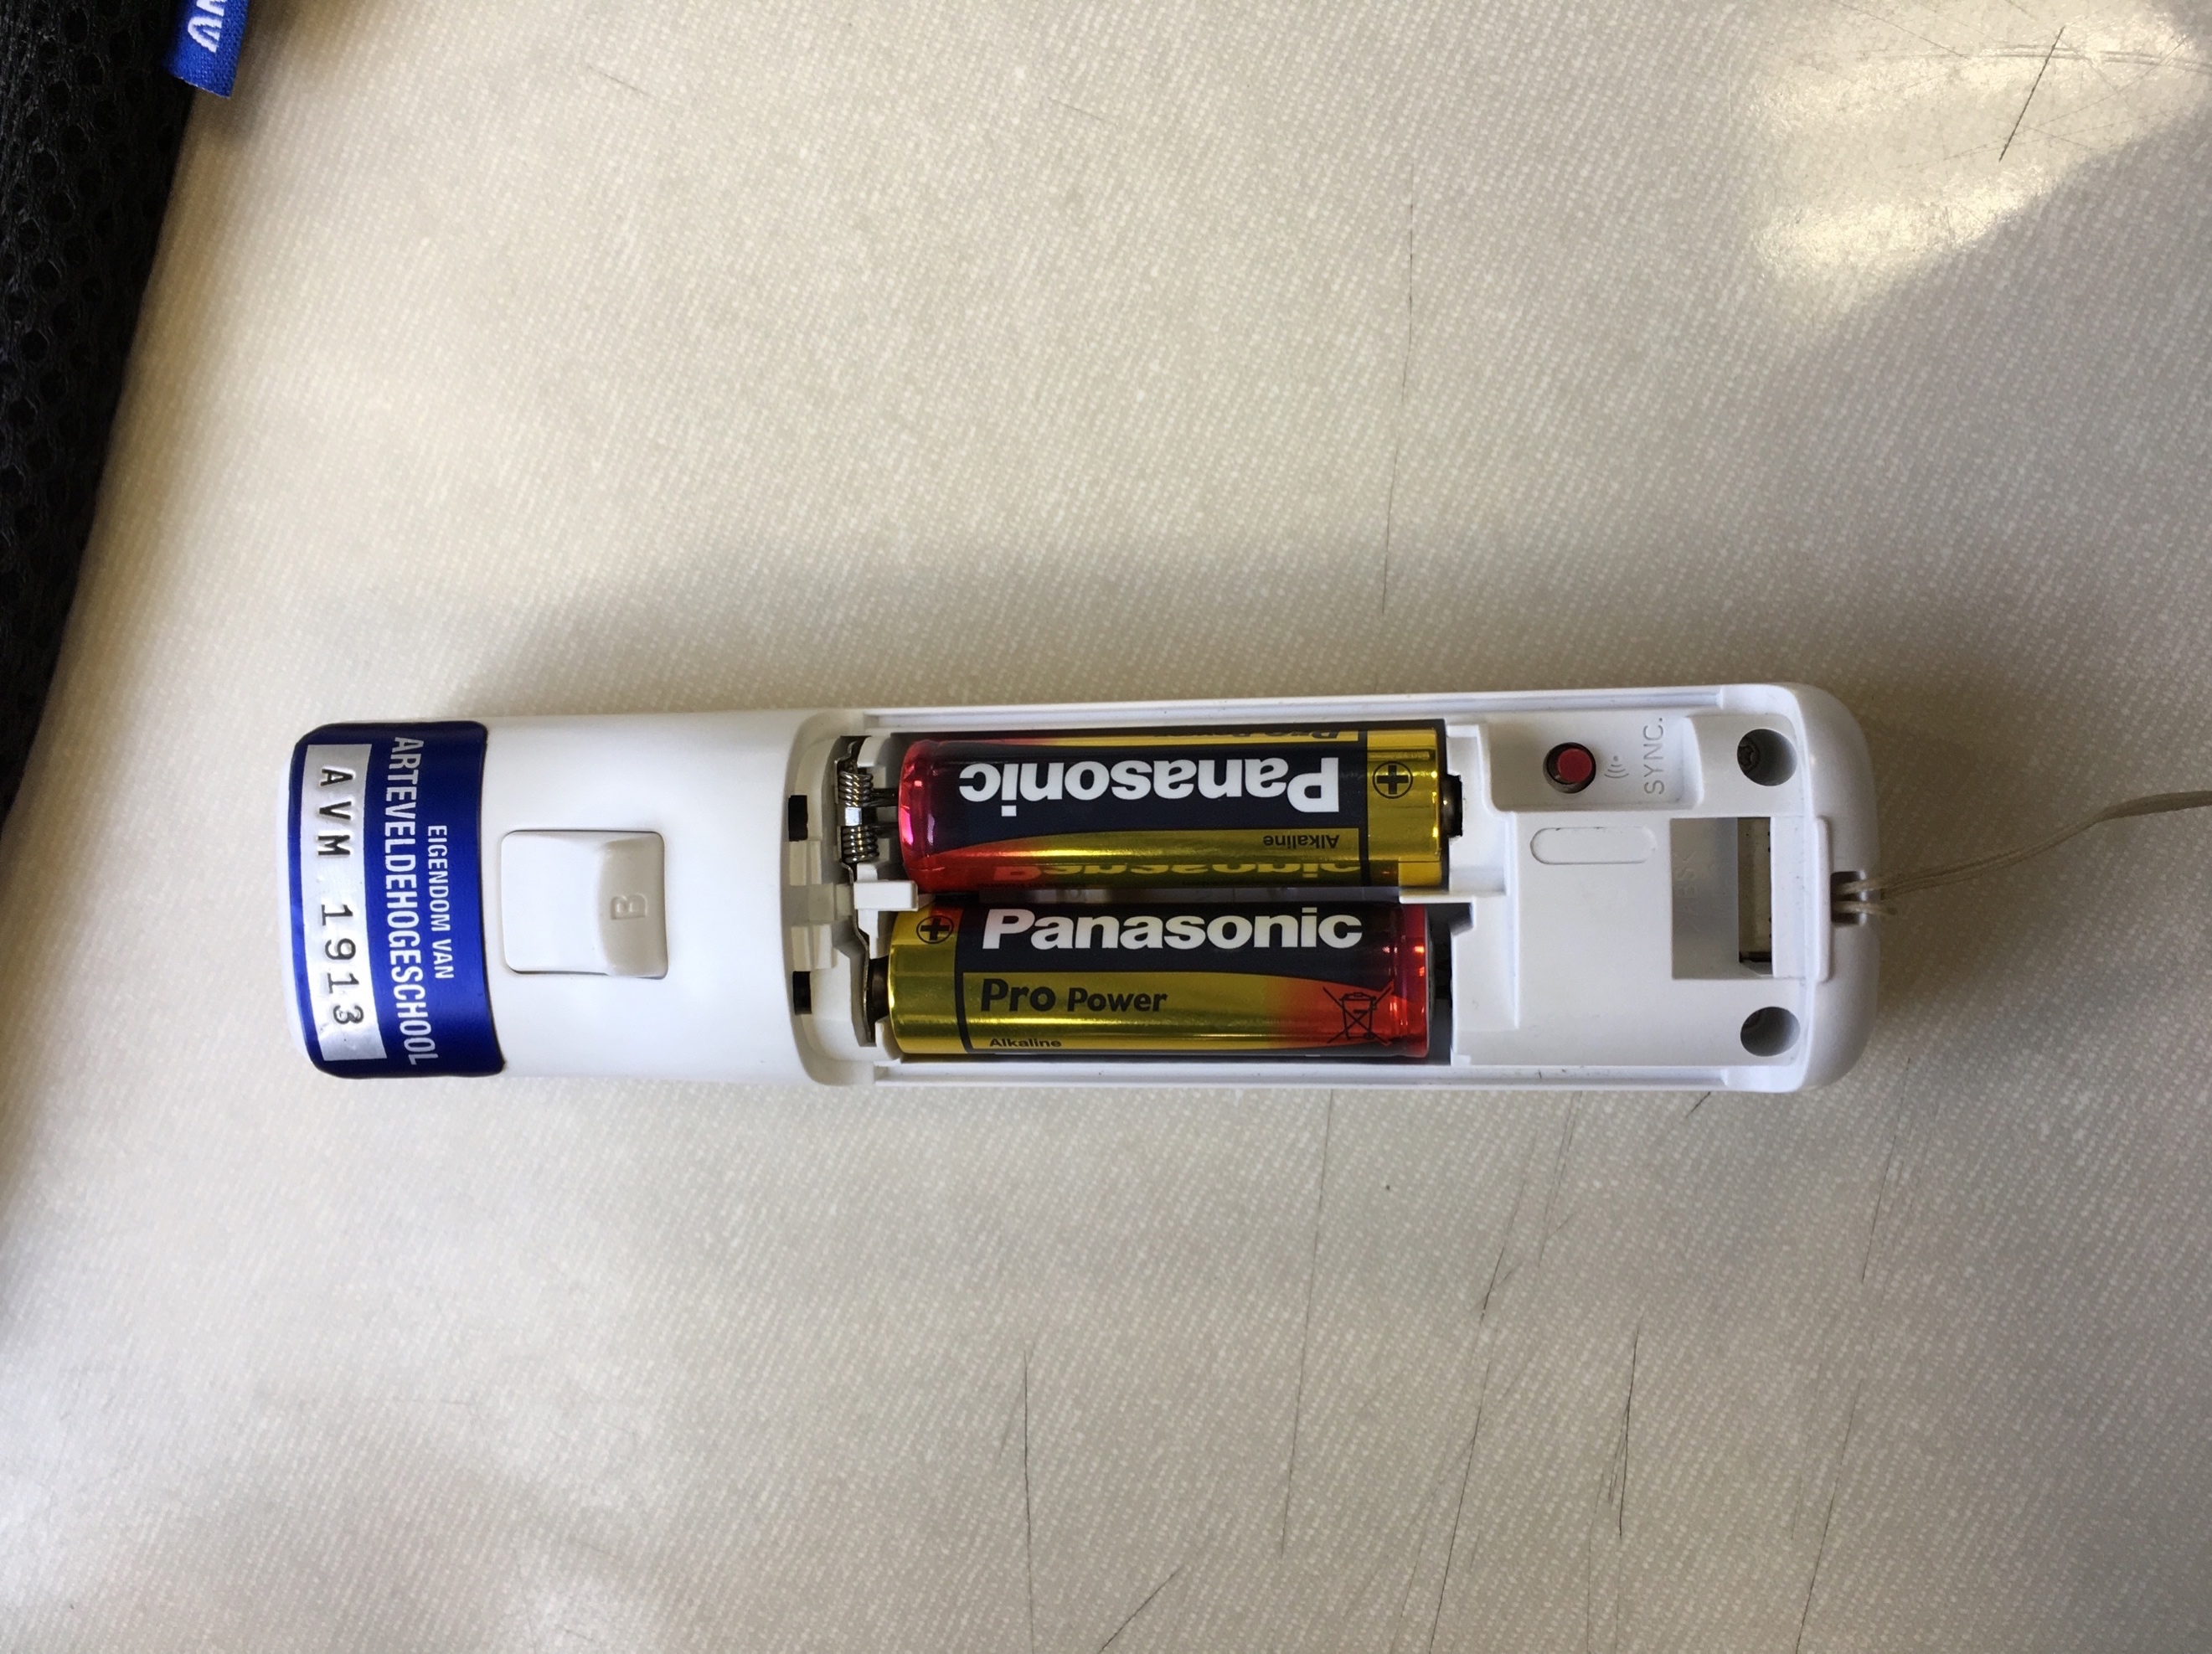 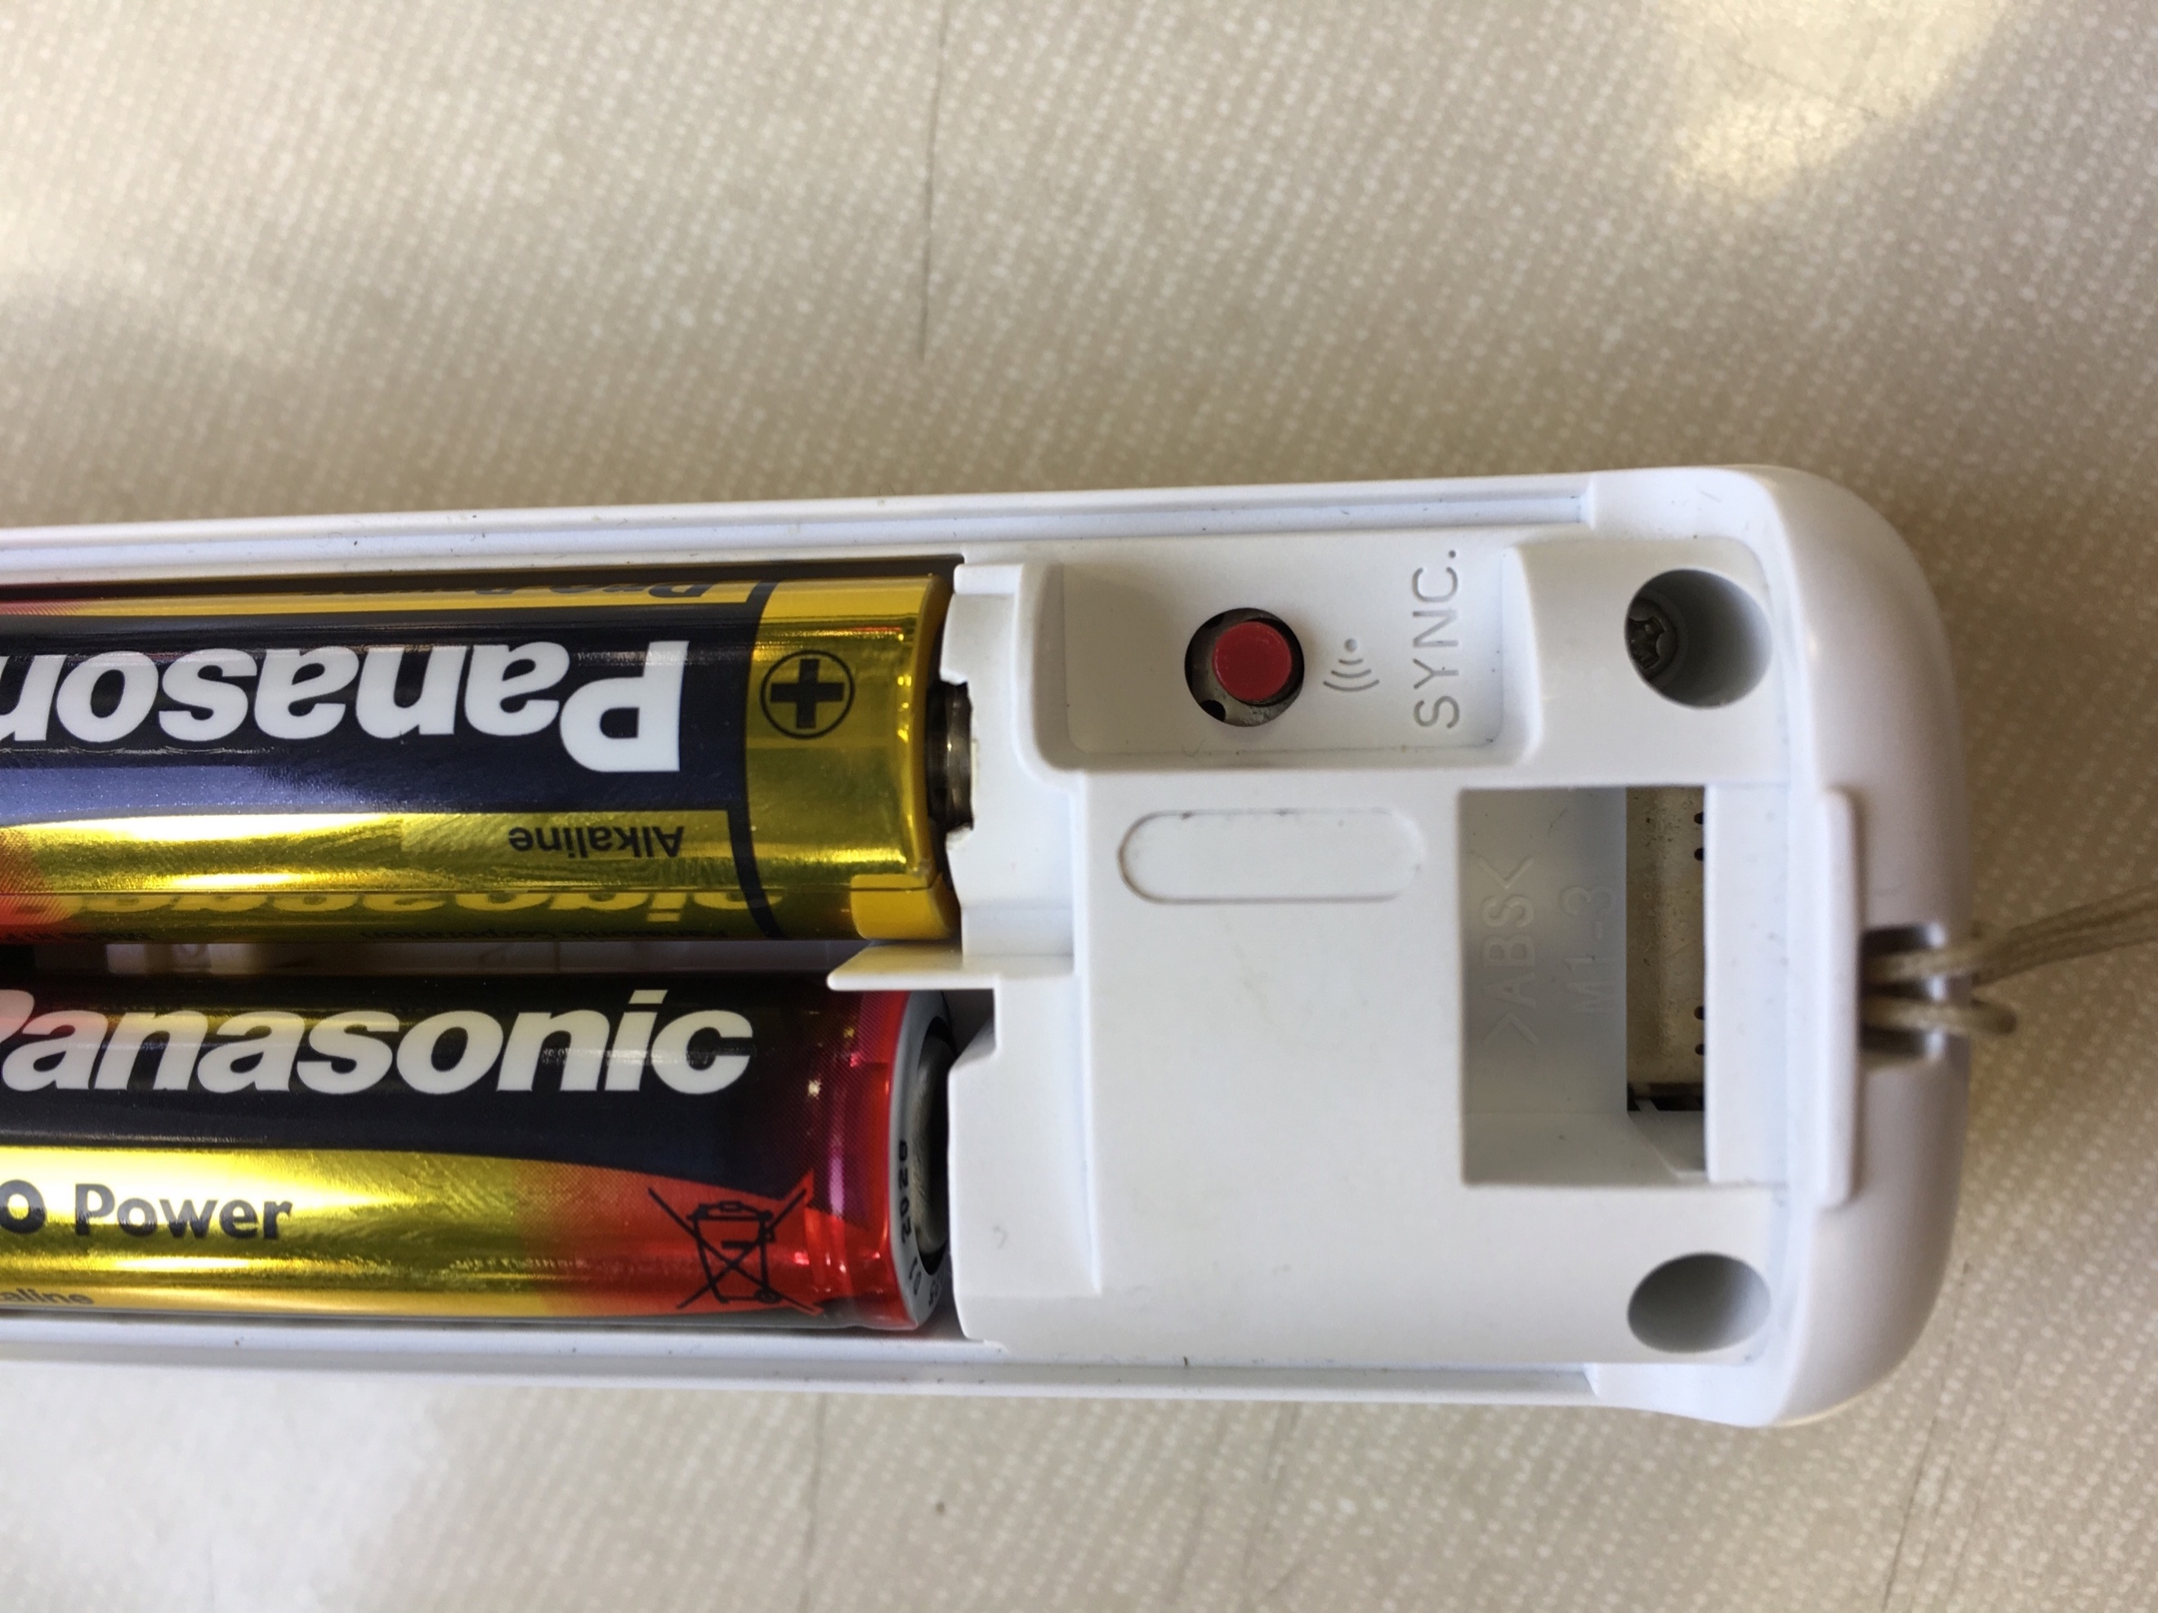

Source3 Source4

## 9. Sources

<https://www.piborg.org>

<https://www.piborg.org/blog/build/rpi-ps3-help>

<https://www.piborg.org/robots/diddyborg-v2>

<https://www.instructables.com/id/Wiimote-Controller-Configuration-for-Raspberry-Pi-/>

<https://www.piborg.org/blog/thunderborg-getting-started>

<https://core-electronics.com.au/tutorials/using-usb-and-bluetooth-controllers-with-python.html>

<https://www.instructables.com/id/Auto-Connection-of-the-Bluetooth-and-Auto-Running-/>

<https://pimylifeup.com/raspberry-pi-wiimote-controllers/>

<https://www.dexterindustries.com/howto/run-a-program-on-your-raspberry-pi-at-startup/>

https://raspberrypi.stackexchange.com/questions/71040/how-to-know-which-file-in-dev-input-event-represent-for-touch-input-device